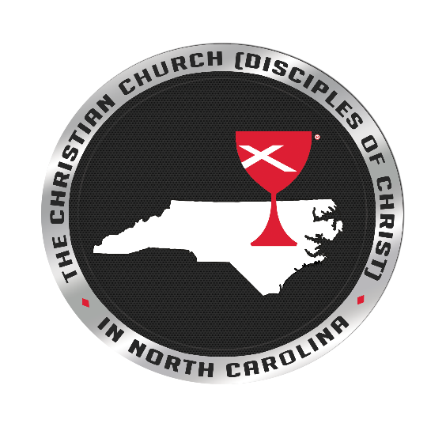

Racial Equity Training

for Clergy & Church Leaders

SAVE THE DATE FOR 2023

Trainings will be in person!

**Race: From Brokenness & Fragmentation to Wholeness**

This virtual anti-racism/pro-reconciliation training is an interactive experience that explores the myths, the mystery, and the making of race in the United States. Based upon core concepts from national anti-racism models, this training is specifically designed with biblical and theological foundations for the Christian Church (Disciples of Christ). Practical tools for pastors & lay leaders are offered through cultural analysis, Bible study, and reflection.



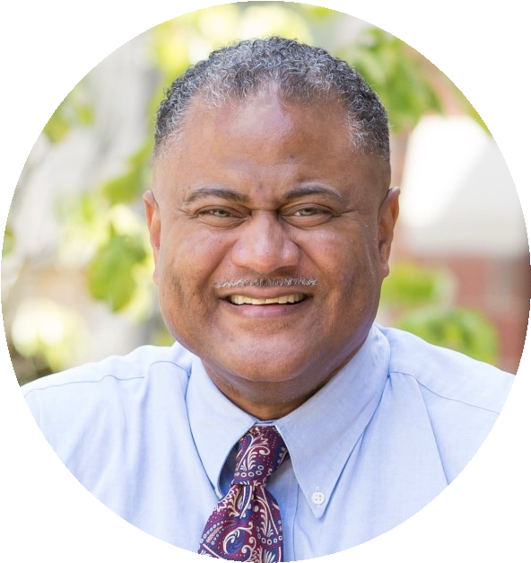

Trainers

|  |  |  |  |
| --- | --- | --- | --- |
| **Rev. Dr. Rodney Sadler**  Professor of Bible  Union Presbyterian Seminary Charlotte | **Ms. Nikkeia Lee** Managing Director  The Possibility Project Charlotte | | **Rev. Jason Williams**  Pastor  Hood Memorial CC  Dunn |
| **Registration Information**  If you request a scholarship, please call Bishop Valerie Melvin at the regional office  (252-291-4047 ext 202).  **Registration Cost - $150 per person**  **(Includes lunch)**  *Resolution 116, passed at the 2016 Regional Assembly held in Greenville, NC, requires all commissionedand ordained ministers who desire to maintain their standing to complete this training.* | | | **2023 Training Schedule**   |  |  | | --- | --- | | January 20-21 | First Christian Church  1900 W. Market Street, Greensboro, NC 27403 | | October 12-13  Sessions Times | First Christian Church  207 Tarboro Street N  Wilson, NC 27893  First day: 10:00am-6:00pm  Second day 9:00am-5:00pm | | |